AdventureDemo

Sam Schock

The AdventureDemo is inspired by early text based adventure and role playing games. I coded the original file in my first semester of Java, before I had learned about methods or any sort of object oriented programming techniques. As I progressed in my education, I continued to improve and update the code, implementing what I learned. It is unpolished and unfinished, but I do think it shows my growth as a coder over the last two years. This is why I am including it in my portfolio.

Contained in the AdventureDemo source folder are 5 files:

**AdventureDemoWorking.java** is the most up-to-date, functional, complete version of the adventure game. Originally coded before I learned about methods & classes. Long, repetitive, clunky code, but a fun game nonetheless. Features random enemy encounters and a branching storyline. Can be completed in less than 5 minutes.

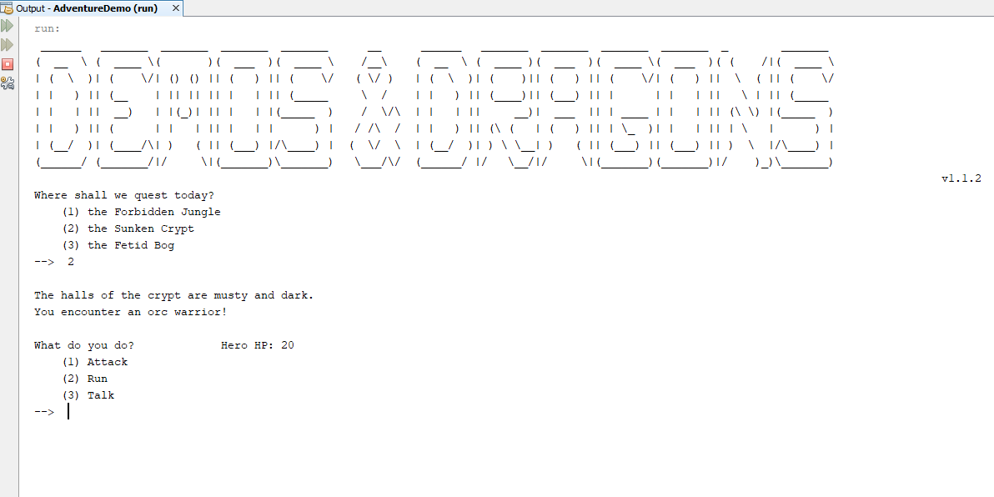

**AdventureDemoV2.java** implements classes and methods for enemies and heroes. The combat loop has been reduced to a single line command. As a result, the code is about 50% shorter than the original demo. However, some flexibility was lost in terms of combat options.

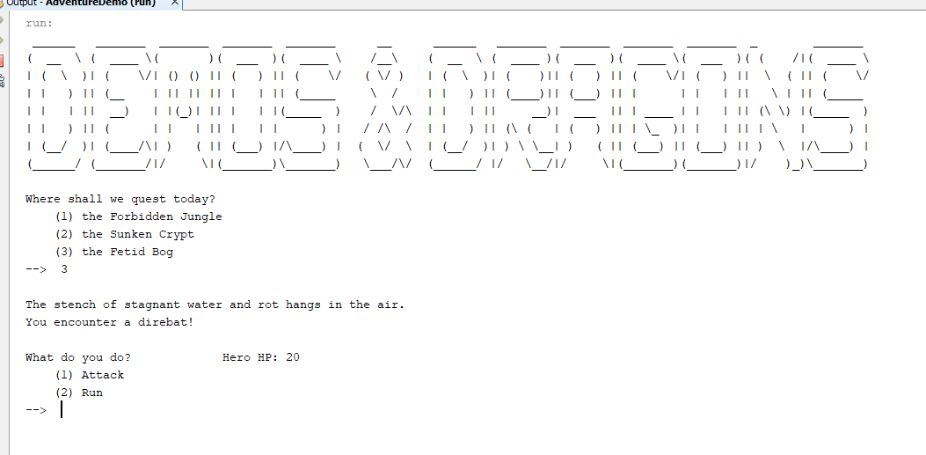

**Enemy.java** and **Hero.java** are both classes created to handle instances of player characters and enemy combatants in the AdventureDemo. Notably, the turn based combat loop is contained as a method of the ‘hero’ class.

**EncounterMethod.java** is an interesting program that I wrote between AdventureDemo v1 and v2. This was my attempt to convert the turn-based combat loop from the game into a method. However, I had not yet learned how to make my own classes, or the basic tenets of object oriented programming. As such, the code uses a series of loops and arrays to construct a table of enemy combatants. The code is obsolete and is not used in v2 of the game. Nonetheless it was a fun exercise, and I include it to show how my coding has progressed.